Dear parents, dear children,
With their First Communion, children are introduced to the community of Jesus Christ and the Church in a deeper way. Now they can participate in the community at the table of Jesus.
On Sunday, 25 April 2027, we will celebrate First Communion in our parish of Santa Clara. Your child has the opportunity to prepare the celebration of First Communion.
We cordially invite you to an information evening on 02 sept. 2026 at 6.30 p.m. in the Lindenbergsaal, Lindenberg 8, 4058 Basel.
For some helpful information on preparing for First Communion, please scan the QR code. There you will find more useful information and the registration form.
If you have any questions, please contact the course coordinator Andrea La Monaca at the following contact details: Tel.: 061 685 94 64, email: andrea.lamonaca@rkk-bs.ch.
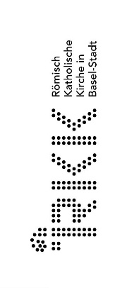
We look forward to accompanying you on this journey.
Andrea La Monaca

